**NAME:_­­­­­___________________**

**John Tonkin College**

**PHYSICS MOTION AND FORCES TOPIC TEST 2019**

*(60 Marks, 60 Minutes + 5 Min Reading, Answers to 3Sig. Fig.)*

**Question 1 (4 Marks)**

A 700.0 kg roller coaster car at the Royal Show is travelling at 5.00m/s as it goes over the top of a hill 40.0 m above the ground

(a) How fast will it go over the next hill which is 33 m high? (3)

*✓*

Total energy is conserved: *✓*

*✓*

(b) In reality the car’s speed will be less than this. What has happened to the “lost” energy?

(1)

*Not lost – converted to other forms of energy (sound, heat)* *✓*

**Question 2 (4 marks)**

A satellite orbits the Earth in a circular orbit at an altitude of 4000 km. Calculate

(a) the centripetal acceleration experienced by the satellite. (2)

ac = g = GM/r2 *✓*

=

= 3.70 m/s2 *✓*

(b) the orbital speed of the satellite. (2)

ac = v2/r

v2 = ac x r *✓*

v2 = 3.70 m/s2 x (6.37 x 106 + 4 x 106)

v = 6.20 x 103 m/s *✓*

**Question 3 (4 Marks)**

A 70 kg skier is on a frictionless slope. He follows a circular path of radius 11.0 m as he goes over a mound and has a speed of 7.60 m s-1 at the top of the circle.

Radius 11.0 m

Skier 7.60 m s-1



Calculate the normal reaction force he experiences from the mound at the top of the circle.

FW Fc

(4)

**FN**

*Consider forces going towards the centre of the circle*

*Correct vectorial analysis (with or without diagram✓)*

*ΣF = mv2 / r = W – N*

*N = W - mv2 / r*

*N = (70 🞩 9.8) – ( 70 🞩 7.62 / 11) ✓*

*N = 318.436 = 318 N ✓ up / away from centre of circle ✓*

**Question 4 (4 Marks)**

In a school experiment students release two billiard balls A and B at the same instant, and the balls run down the identical tracks, one 50cm directly above the other.

A

B

(1)

a) Where is ball A most likely to land in relation to Ball B? (Neglect the effect of air resistance and friction)

A. Ahead (in front) of ball B

B. on top of ball B

C. behind ball B

Answer B *✓*

b) Explain your choice

*The upper ball’s gravitational acceleration has no effect on its horizontal displacement so the upper ball lands on top of the lower ball. ✓✓✓*

(3)

**Question 5 (4 Marks)**

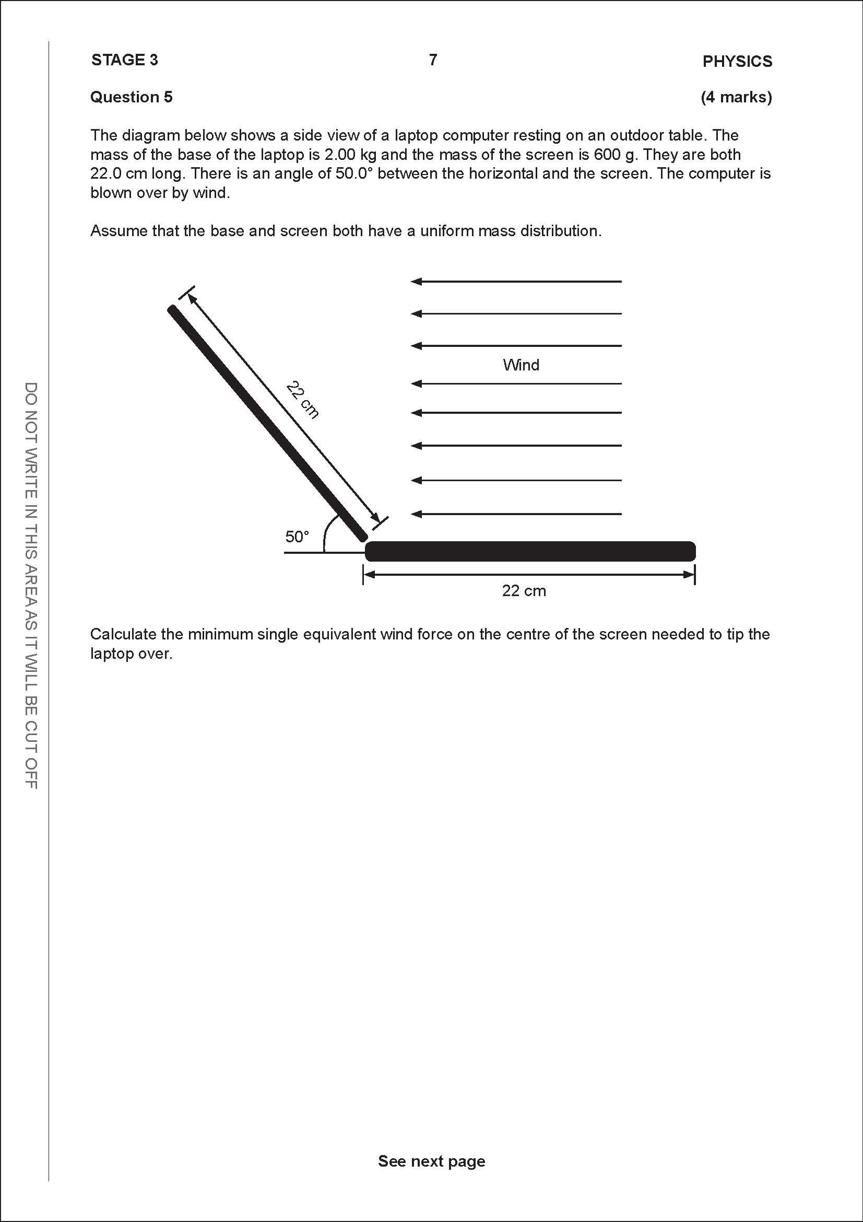

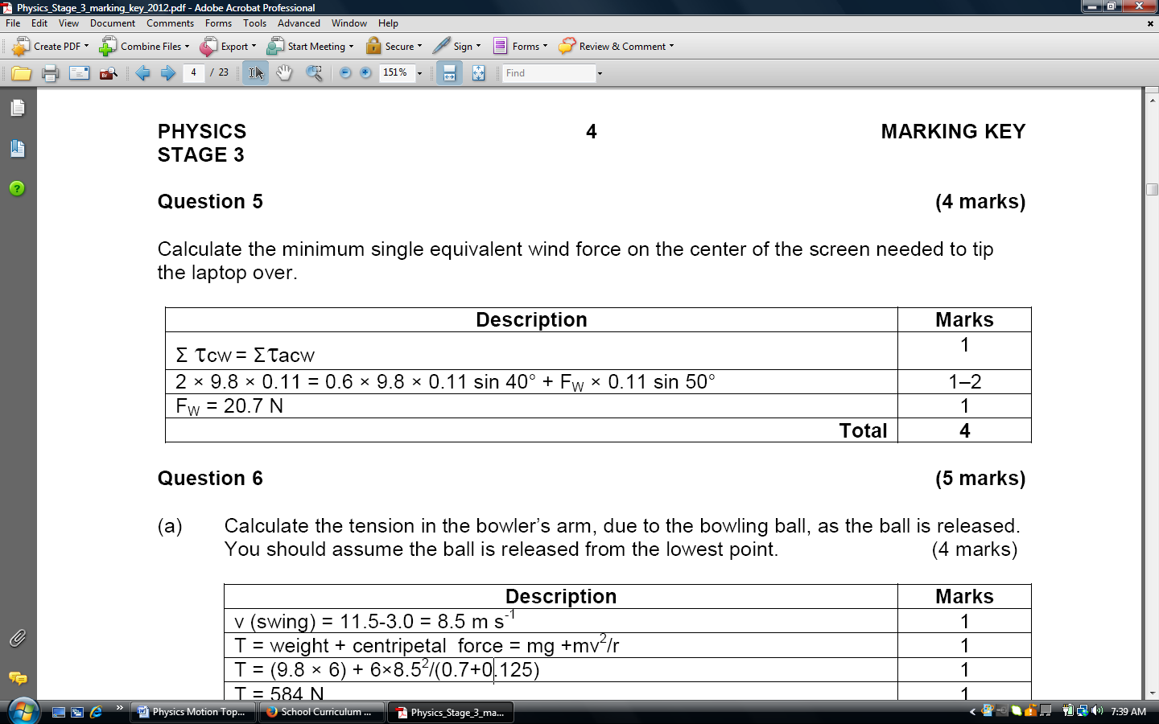

(4)

**Question 6 (12 marks)**

Our Sun is a medium sized star that is part of a spiral galaxy called the Milky Way. Like all spiral galaxies, the stars in the Milky Way rotate around a galactic centre. Our Sun’s orbit is virtually circular with a radius of about 2.5 x 1020 m (about 26000 light years); its average orbital speed is about 2.2 x 105 ms-1.

a) Calculate the orbital period of the Sun around the galactic centre of the Milky Way (in years).

(4 marks)

**1 mark**

**1 mark**

**1 mark**

**1 mark**

b) Calculate the gravitational field strength due to the Milky Way galaxy at the Sun’s distance from the galactic centre. (3 marks)

**1 mark**

**1 mark**

**1 mark**

c) The circular orbit of the Sun around the galactic centre of the Milky Way is due to the gravitational force of attraction between the Sun’s and Milky Way’s centres of mass.

Use the data provided and answers calculated thus far to show that the mass of our galaxy must be about 1.8 x 1041 kg. [If you could not calculate an answer to part a), use 7 x 1015 s; if you could not calculate an answer to part b), use 1.9 x 10-10 Nkg-1] (3 marks)

**1 mark**

**1 mark**

**1 mark**

d) If the mass of our Sun can be considered to be an average mass for the stars in our galaxy, estimate how many stars there must be in the Milky Way. Show working.

(2 marks)

**1 mark**

**1 mark**

**Question 7 (11 marks)**

A stone of mass 520 g is thrown from a building of height 30 m. The stone is launched with an angle of elevation of 38.0⁰ above the horizontal. It takes a time of 3.15 s for the stone to reach ground level. You can ignore air resistance for this question.

30.0 m

range

38°

Building

Initial launch speed **u**

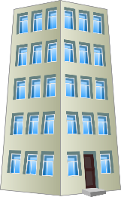

a) Calculate the initial launch speed **u** of the stone. (4 marks)

sy = -30.0 uy = u.sin 38 ay = -9.80 m/s2

ux = sx / tf ux =u.cos 38 tf = 3.15 s

sy =uy tf + ½ ay tf2

-30 = uy x 3.15 – 4.9 x (3.152) ✓

18.6205 = uy x 3.15

uy = 5.91119 s ✓

uy = u.sin 38 = 5.91119 ✓

u = 9.60 m/s ✓

For the following calculations use a numerical value of 9.60 m s-1 for the initial launch speed of stone.

b) Calculate the horizontal range of the stone. (2 marks)

u = 9.60 m s-1 tf = 3.15 s ux = sx / tf

ux =u.cos 38

ux = 9.60 x cos 38 = 7.5649 m s-1 ­right ✓

sx = ux x tf = 7.5649 x 3.15 = 23.8 m ✓

c) Calculate the velocity of the stone after 2.50 s of flight. You must give a magnitude and direction.

(5 marks)

u = 9.60 m s-1 ux =u cos θ = +7.5649 m s-1 ­right

uy = u.sin θ= +5.91 m s-1

In the vertical

uy = u.sin θ= +5.91

vy =uy + at = 5.91 + (-9.8 x 2.5) ✓

vy = -18.59✓

✓

Angle of descent, θ = tan-1 (18.59 / 7.5649) ✓

θ =67.9⁰ ✓

**Question 8 (12 Marks)**

The diagram below shows a person holding a model aeroplane in horizontal circular motion by a light rope, which is at an angle of 35º to the horizontal.

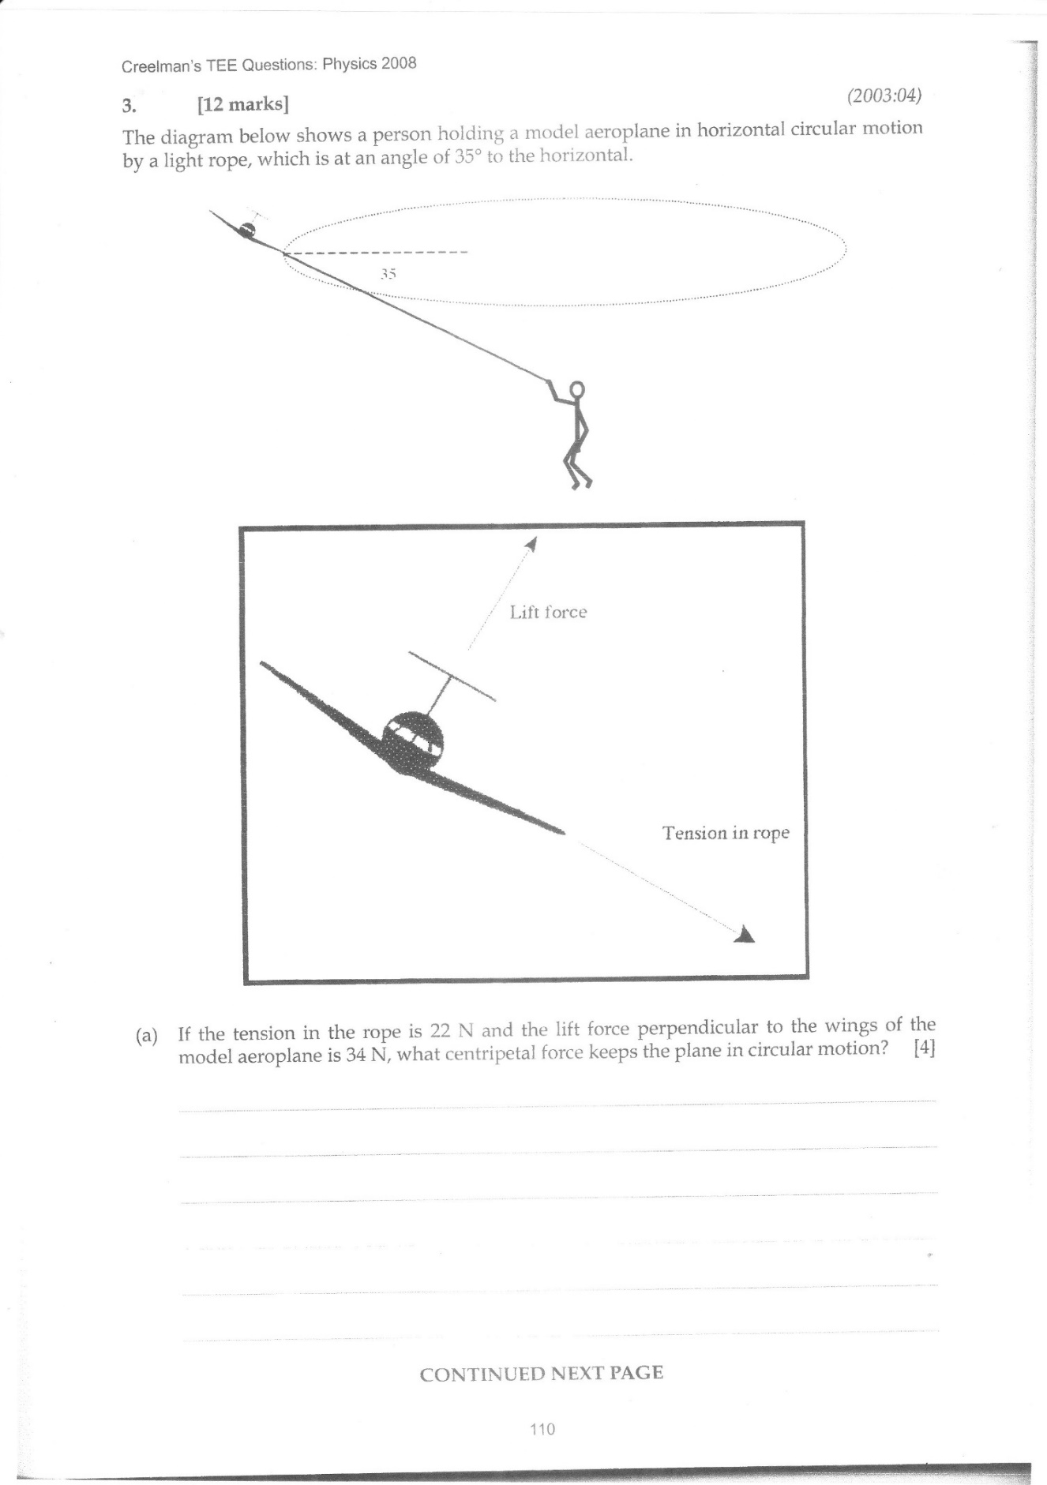a) If the tension in the rope is 22N and the lift force perpendicular to the wings of the model airplane is 34N, what centripetal force keeps the plane in circular motion?

35º

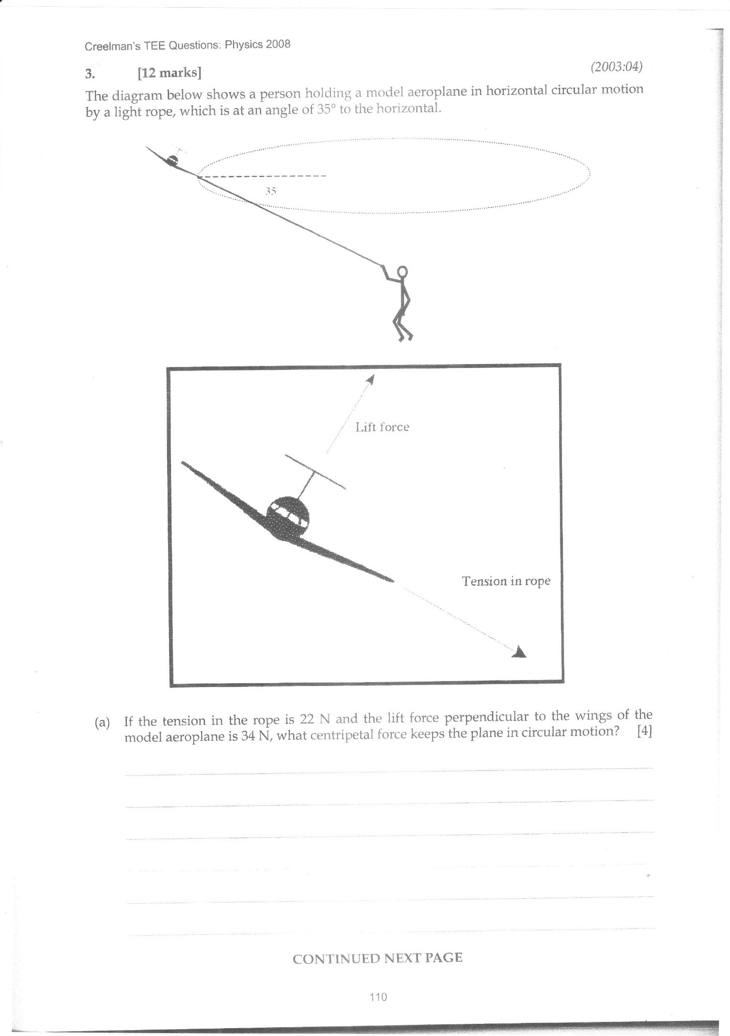

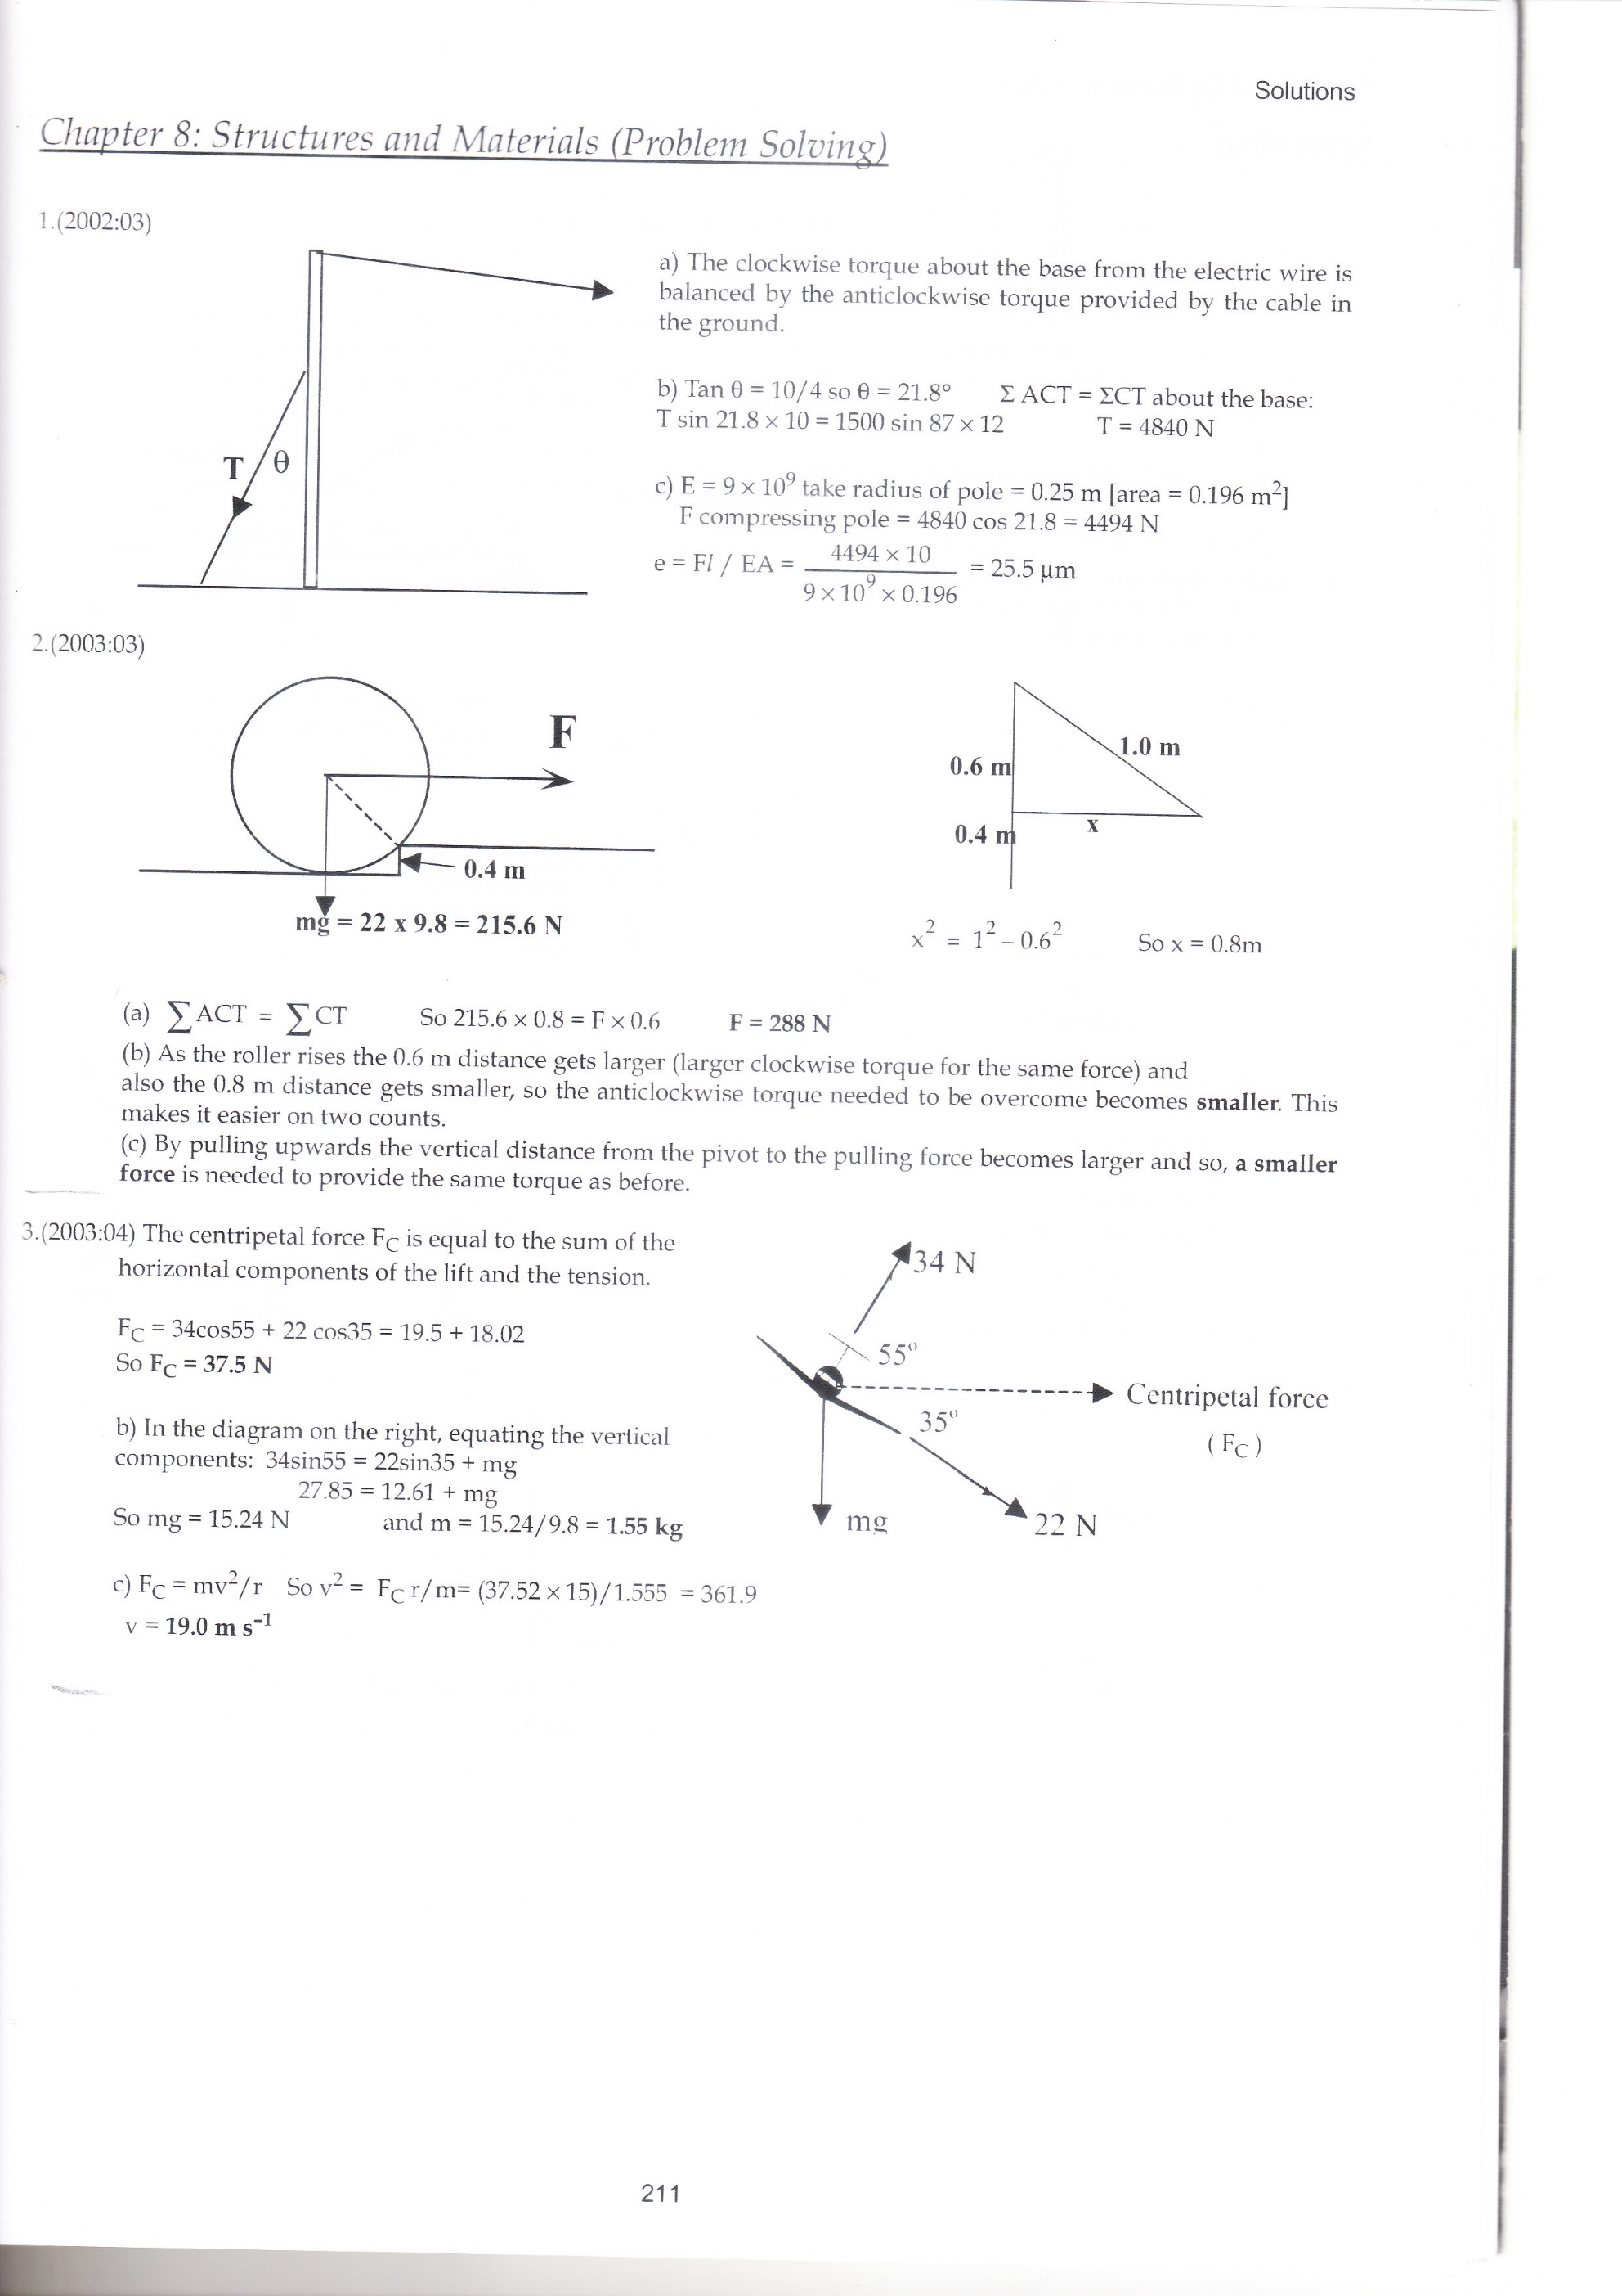

✓

✓

✓

✓

*(4 Marks)*

b) What is the mass of the model airplane?

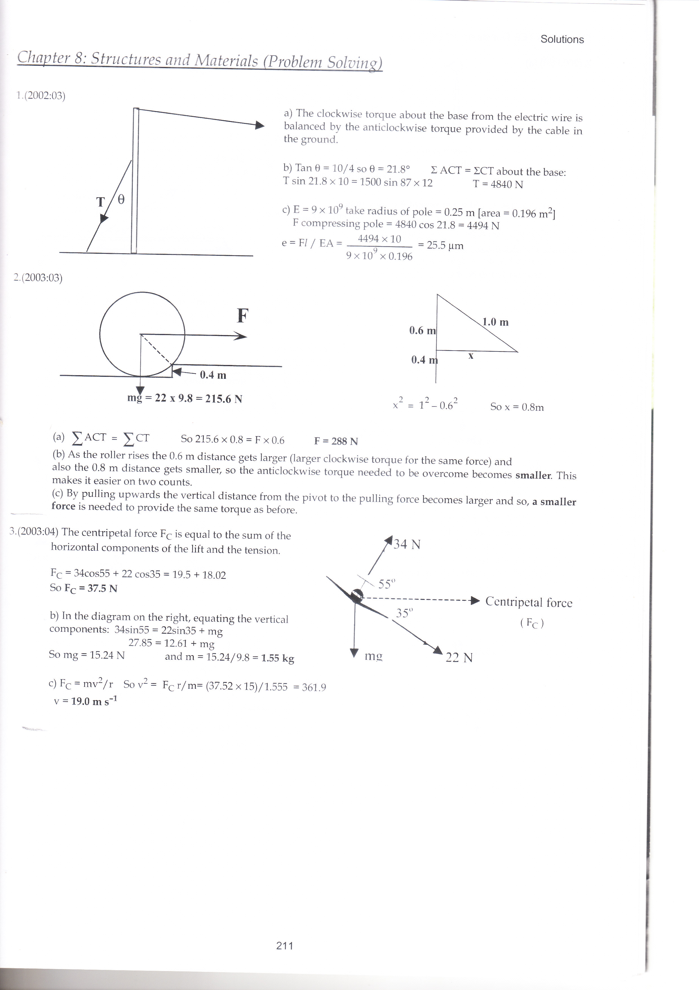

✓

✓

✓

✓

*(4 Marks)*

c) What will be the speed of the model airplane if it moves in a circle with a radius of 15m?

✓



✓✓

✓

*(4 Marks)*

**Question 9 (5 Marks)**

The rigid arm of a crane is lifting an oil drum.

* The crane arm has a mass of 230 kg distributed uniformly along its length of 7.00 m.
* An oil drum of mass 310 kg is suspended 4.80 m from the pivot point of the crane arm.
* A cable is attached 6.10 m from the pivot point and transmits a tension force of 3964.5 N.
* The cable makes an angle θ with the crane arm.
* The crane arm has been raised to 32° above the horizontal.

7.00 m

6.10 m

4.80 m

*Crane Arm*

*Cable*

32°

θ

*Oil drum*

1. Calculate the angle θ between the crane arm and the cable.

(4)

Select base as pivot point and take moments such that ΣM = 0

Σcwm = Σacwm correct concept

(4.8 x 310 x 9.8 x sin 58) + (3.5 x 230 x 9.8 x sin 58) ✓ = (6.1 x 3964.5 x sin θ)✓

Sin θ = 0.7880 ✓

θ = sin-1 (0.7880) = 52.0⁰ ✓

1. If the oil drum is instead suspended from the right hand edge of the crane arm the tension in the cable will: (circle a response)

(1)

Increase Stay the same Decrease Impossible to determine